An Ann Approach for Ergonomic Evaluation of Peddle Driven Sewing Machine Operators for Study of Process Time
Swapna Ghatole ¹, Yashpal ², Mahesh Bundele ³ and J.P. Modak ⁴ +
¹ “ Research Scholar , Poornima University”, Jaipur (MS), India, swapnaghatole72@gmail.com
2 Associate Professor, Poornima University”, Jaipur (MS), India
3 “Principal & Director , Poornima College of Engineering”, Jaipur (Rajasthan), India, maheshbundele@poornima.org
4 “Technical Advisor , Prof. Emeritus ,J.D. College of Engineering” Nagpur (MS), India, jpmodak@gmail.com

Corresponding Author : Swapna Ghatole, swapnaghatole72@gmail.com
Mobile No. 09420253255

Abstract: Present study is conducted in Nagpur city where sewing machine work is one of the busy working operation in culturally background country like India. The study aims to execute the analysis of ergonomic tools and ANN approach for process time in connection with the musculoskeletal disorders (MSD) of operators. These operators are using seating stools which are not ergonomically designed. The investigation is led on 30 male sewing machine operators working on peddle driven sewing machine with experience of 10 to 12 years. This activity is portrayed by a static sitting stance , with forward angular tendency of head and trunk. The operators are using stools without back support. Ankle and knee are positioned in awkward angles, the eyes are required to continuously observe the work of sewing , while the hands are constantly coordinating the sewing material with the assimilation of vibrations on working surface of sewing table,to catch up the time constraint given to clients. The legs and feets are continuously working for steady and speedy control of work. The study has demonstrated the application of ergonomic tools for analysis of musculoskeletal loads. The operator’s score with the help of RULA and REBA ergonomic tools for elbow to wrist position, neck to shoulder position and lumber region was found above limits of risk . The need of immediate change in the working postures and creation of ergonomic awareness in standalone sewing machine operators is felt. Help of Artificial Neural Network approach is taken to reduce the risk of msd on body postures. ANN simulation is established for 1 dependant Pi term Z1 (process time), and 5 independent Pi terms . The final model established with the help of ANN shows the clear nearness with the mathematical model established by regression analysis method .
Keywords: Musculoskeletal load ;manually driven sewing machine; RULA and REBA ; ANN
1.0 INTRODUCTION

Manually driven sewing machine operation is a very common feature in central India. This is an unorganized sector mostly run by private/ single establishments by single stand alone machine operator. Various work related musculoskeletal disorders(MSD)[1,2] have been experienced by these operators resulting in occupational health hazard and lowering down their productivity levels with more process time taken . This article deals with scientific evaluation of the musculoskeletal disorders[7, 10] based on ergonomic considerations. Stand alone sewing machine operators work around the city for nearly 9-10 hours a day. This work is having large repetitive actions and involves static movement of sitting on stool. Due to which the operators are under high risk of MSD[10]. This study helps to identify the high risk posture during process of sewing and reducing the process time for per stitching cloth by implementing the preventive steps while working.
2.0 METHOD and PROCEDURE
Thirty operators were selected for the study. Initially data was collected by interview technique for obtaining the personal information, information regarding job specialization and health related issues, including musculoskeletal parameters such as age, experience, height with sitting, sitting eye height, sitting height from elbow, knee height, buttock knee height, popliteal height, span between elbow, length of leg, arm reach, inclination of head, inclination of eyeball, inclination of back w.r.t to table. Dutch musculoskeletal questionnaire was used as basis for preparation of questionnaire according to Indian Context.
The operators anthropometric data and machine dimensions were collected [1,2]. In this work 38 independant quantities are identified . Their MLT units are written and the dimensionally homogeneous groups of 38 independant terms are formed [1,2,8]. As required by dimensionally homogeneous groups independent and dependant Pi terms are defined[11]. All the quantities are converted into dimensionless formula. Total five Independent Pi terms such as Π _{1,} Π _{2,} Π _{3,} Π _{4,} Π ₅ and one Dependant Pi term ( Z1) [12,14,22] is identified as shown in Table1.
Table 1 : Pi terms defined as Independent and Dependant
Sr. No. | Pi terms | Explanation
1 | Π ₁ | Operator’s Anthropometric data
2 | Π ₂ | Operator’s Personal data
3 | Π ₃ | Workplace Environmental conditions
4 | Π ₄ | WorkStation Specification
5 | Π ₅ | Specifications of parts of pedal sewing machine and their condition.
6 | Z1 | Process time

Process time is defined as Z1 [13,22] required for stitching the cloth. The Z1 calculations are done by the formula :
Z1 = ( Tshl / Shl) * Stl where
Tshl = Time required / length of cloth
Shl = Stitching length of cloth
Stl = Stitching length/ day

2.1 PROCEDURE for Work
Initially the data collected was studied for ergonomic tools RULA and REBA[18].Rapid upper limb assessment(RULA) tool was applied for evaluation of musculoskeletal load as work involves, repetition of work and force and awkward sitting posture. In RULA tool the upper body parts are classified in two Groups namely A, B. Group A is for Upper Arm which includes Shoulder, Elbow & Wrist . Group B includes Neck , Trunk & Legs. This tool requires no special equipment in providing a quick assessment of the postures of the neck, trunk and upper limbs along with muscle function and the external loads experienced by the body.
The Rapid Entire Body Assessment (REBA) tool is also used for comparative study of the whole body parts classified as Group A and Group B. Group A consists of neck, leg and trunk and Group B is for study of arm and wrist . The complete study is done with the help of standard RULA Sheet and REBA Sheet[18]. Comparative analysis of scores from both the studies are done and shown graphically in Figure 1. The study shows that, these operators are working at potentially high ergonomic risk for entire body.
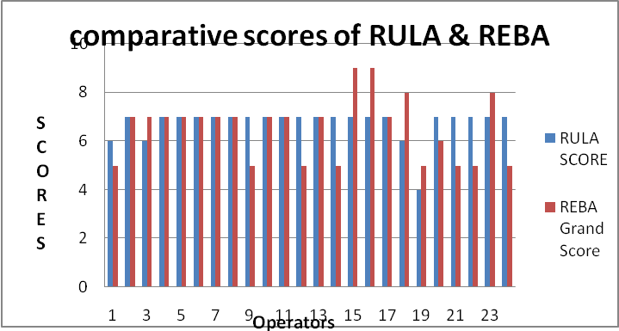
Operators Score
Figure 1: Graphical Analysis of RULA & REBA
Further as shown in the Figure 2 graphical analysis of operators working under risk zones of MSDs are depicted. It shows that around 83-75 % of the specialists were working at high danger levels. It was seen that, if the specialists kept on working in a similar posture they will experience the ill effects of the MSDs related to wrist, neck, and trunk. They are working under high physical strain and needs immediate change in their working style and workstation designs. Around 17- 25 % of the specialists in the jobs were at second order of danger levels and will require a change at the earliest [9,10].
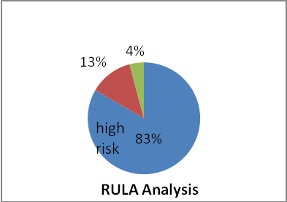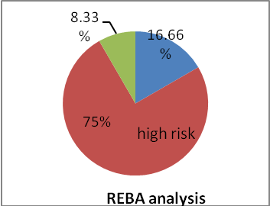
Figure 2 :Percentage of operators in risk zone
Most of them had upper arm and lower arm injury as they are working under high strain due to continuous vibrations to the complete hand [5,6,8]. Due to this the operators were recommended to keep their trunk straight while working. In most of the conditions they were encouraged to take rest in the middle of customary long periods of working.
By observation it was noted that some of the sewing machine specialist in the sewing jobs were bending their trunk to unacceptable limit due to stature of seating stool.
Further ANN formulation was done to diminish the MSDs in reduction for per stitching cloth process time.
2.2 Procedure for formulation of ANN Process:
The gathered information from the field is isolated into two sections viz. input information data of independent pi terms as shown in Table 1 and the output data of dependant pi (Z1) term[14,15,20]. The input and output data is read by preset function and appropriately sized. In preprocessing step the input and output data is normalized using mean and standard deviation. The input and output data is then categorized in three classifications of testing, validation, and training from 30 observations.
The ANN with the help of neural fitting tool (nftool) divided the samples as 70% data samples for training, 15% for Validation and 15% for Testing. The ANN topology in a conventional manner is decided for the case with 1 neuron in output layer corresponding to one dependant quantity and 5 neurons in input layer corresponding five independent Π terms[9,10,11] .The number of hidden Neurons are 10 as shown in figure 3.
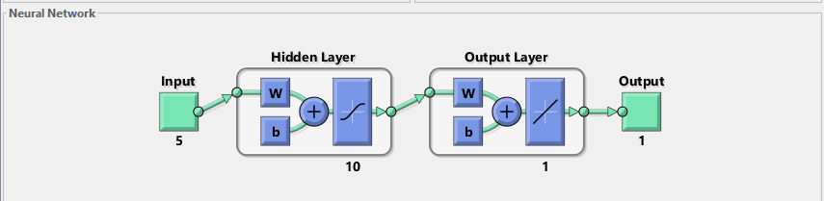
Figure 3: Hidden Neurons and input output layer
The network is trained for training the data by using feed forward back propagation method. The computation errors in the actual and target data are computed and then the network is simulated. The study shows that perfect regression plots nearing to 1.
After simulating the ANN, it is found that experimentally observed values are very close and in good agreement with the ANN predicted values. The regression plots are shown in figure 4.

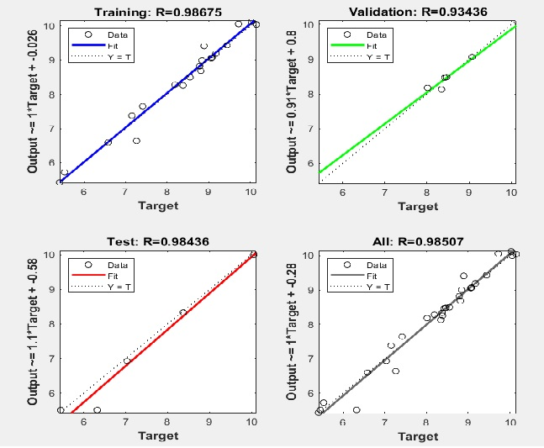
Figure 4: Regression plots of the ANN
The data comparisons between actual calculated experimental data, mathematical model data and ANN data for process time are in close nearness with each other as depicted by figure 5 .
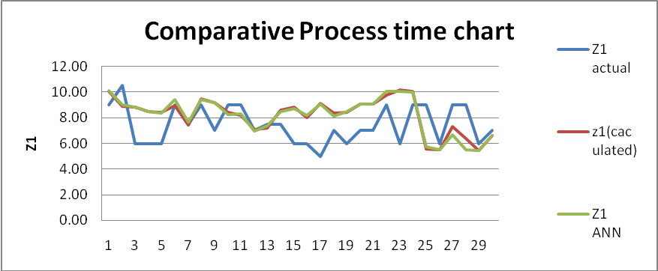
Figure 5: Comparison between Actual calculated data, Model based data and neural network based data
The comparative performance analysis of actual field data , mathematical model data and ANN data and errors between the ANN and caluculated model data along with its percentage of errors are depicted in table 2 . This table 2 explains the nearness of the data which helps us to decide that mathematical model and ANN model data can be utilized for further workstation design with ergonomic intervention to reduce the fatigue in operators with improvement in process time of per stitching cloth.

Table 2. Performance analysis of ANN and Comparison of field data reducing process time (Field data),the (Mathematical Model), THE (ANN Simulation), Error between ANN & Field data, Error between ANN & calculated model data, % Error between ANN & Field data

Sr. No | Z1 Field Data | Z1 Mathematical model data | Z1 ANN data | Error = (Z1 Field data - Z1 Mathematical model data) | % Error ( Z1 Mathematical model - Z1 Ann) | % Error between ANN & Field data
1 | 9.00 | 10.03 | 10.1162 | -1.03 | 0.09 | 1.12
2 | 10.50 | 8.84 | 8.9959 | 1.66 | -0.16 | -1.50
3 | 6.00 | 8.78 | 8.8184 | -2.78 | -0.04 | 2.82
4 | 6.00 | 8.46 | 8.4811 | -2.46 | -0.02 | 2.48
5 | 6.00 | 8.37 | 8.3308 | -2.37 | 0.04 | 2.33
6 | 9.00 | 8.89 | 9.4096 | 0.11 | -0.52 | 0.41
7 | 7.50 | 7.41 | 7.6472 | 0.09 | -0.24 | 0.15
8 | 9.00 | 9.44 | 9.4312 | -0.44 | 0.01 | 0.43
9 | 7.00 | 9.17 | 9.1871 | -2.17 | -0.01 | 2.19
10 | 9.00 | 8.38 | 8.2538 | 0.62 | 0.13 | -0.75
11 | 9.00 | 8.19 | 8.2768 | 0.81 | -0.09 | -0.72
12 | 7.00 | 7.03 | 6.9241 | -0.03 | 0.10 | -0.08
13 | 7.50 | 7.15 | 7.3795 | 0.35 | -0.23 | -0.12
14 | 7.50 | 8.55 | 8.4954 | -1.05 | 0.05 | 1.00
15 | 6.00 | 8.81 | 8.685 | -2.81 | 0.12 | 2.69
16 | 6.00 | 8.01 | 8.1787 | -2.01 | -0.16 | 2.18
17 | 5.00 | 9.08 | 9.0705 | -4.08 | 0.01 | 4.07
18 | 7.00 | 8.34 | 8.1281 | -1.34 | 0.22 | 1.13
19 | 6.00 | 8.42 | 8.4639 | -2.42 | -0.05 | 2.46
20 | 7.00 | 9.07 | 9.0643 | -2.07 | 0.00 | 2.06
21 | 7.00 | 9.06 | 9.0537 | -2.06 | 0.01 | 2.05
22 | 9.00 | 9.72 | 10.0565 | -0.72 | -0.33 | 1.06
23 | 6.00 | 10.15 | 10.0425 | -4.15 | 0.11 | 4.04
24 | 9.00 | 10.05 | 9.9958 | -1.05 | 0.05 | 1.00
25 | 9.00 | 5.53 | 5.721 | 3.47 | -0.19 | -3.28
26 | 6.00 | 5.45 | 5.5041 | 0.55 | -0.06 | -0.50
27 | 9.00 | 7.26 | 6.6376 | 1.74 | 0.63 | -2.36
28 | 9.00 | 6.32 | 5.506 | 2.68 | 0.81 | -3.49
29 | 6.00 | 5.41 | 5.4248 | 0.59 | -0.01 | -0.58
30 | 7.00 | 6.58 | 6.5937 | 0.42 | -0.01 | -0.41

3.0. Conclusion

The assessment of body posture was completed for the sewing machine operators by score sheet of RULA and REBA ergonomic tools. It was seen that 83-75 % of the workers are working in awkward and difficult body position. This is due to less knowledge of ergonomics and awareness in unorganized sector. Thus the workers are under extreme level danger of musculoskeletal disorders as seen from REBA and RULA risk levels. This study recommends the immediate implementation of ergonomic interventions with proper knowledge about musculoskeletal risk among workers while working.
The RULA and REBA tools concluded that the operators in the sewing jobs were bending their trunk to unacceptable limit due to height of stool with respect to working table, hence they may have musculoskeletal disorders with neck and lumber portion at present or in near future. Health impact on common postural change, implementation of ergonomic knowledge among small scale industries are recommended to lower down morbidity due to musculoskeletal disorders. Because musculoskeletal risk is directly proportional to financial aspect of family. This also was validated by various [4, 5, 7,8] studies on sewing machine operators.
Further ANN Simulation model was developed for analysis of prediction of process time of sewing machine operators considering Anthropometric data, Personal data, Environmental data, machine variables and machine workstation data as independent variables.
The comparison of values of dependent pi term i.e. Process time (Z1) obtained by field data, mathematical model, and ANN model are shown in Table 2[17,20].The significance of this model can very well be seen from the data presented in actual field data column, mathematical model values and the predicted ANN simulation strength in Table 2. All these values shows nearness very well with each other. From the values, it seems that the mathematical models and the ANN developed can be effectively used for calculation of dependent terms for a assumed set of the independent pi terms. The Figure 5 depicts that the comparison made by Field data, Mathematical model values and ANN gives the response data which is overlapping[12,15,17,22] . The overlapping curves are due to less percentage error amongst the Models. This proves the authenticity of the responses for reduction of process time per stiching cloth by implementation of few ergonomic interventions with proper knowledge about musculoskeletal risk.
References :

1 | Swapna Ghatole, V.S.Deshpande, J.P. Modak, Formulation of Field DataBased Model of Productivity for Standalone Sewing machine operation based on Ergonomic Consideration, , Advances in Physical Ergonomics an Human Factors , pp 411-421,Springer Nature, 2017
2 | Swapna Ghatole, Yashpal, Mahesh Bundele and J.P. Modak , Development of mathematical model for reduction of process time for peddle driven sewing machine. Proceedings of International Conference on Intelligent Manufacturing and Automation, Lecture Notes in Mechanical Engineering, pp 513-521, Springer Nature, 2020 https://doi.org/10.1007/978-981-15-4485-9_53
3 | Tuhar Kanti saha , Aparajita Dasgupta, Arindum Butt, Onkarnath Chattopadhyay, Health status of workers engaged in the small scale garment industry : How healthy are they? , Indian jounal of community Medicine, vol 35, jan 2110
4 | Pizmot P, Polanjar A, Leber M Fulder T.,Ergonomically designed workstation based on simulation on workers movement," Int. journal of dimulation and modelling, vol. 1, pp. 27-34, 2005.
5 | N. Kamalamma, A.K. Ganguli P. Parimalam, Ergonomic interventions to improve work environment in garment manufacturing units, Indian journal of Occupational and Environmental Medicine, vol. 10, pp. 74-77, 2006.
6 | Nico J. Delleman Jan Dul , Sewing machine operation:workstation adjustment, working posture, and workers’ perceptions, International Journal of Industrial Ergonomics 30 (2002) 341–353
7 | Ira Janowitz Pin-Chieh Wanga, David M. Rempel, Eric L. Hurwitze, Robert J. Harrison and Beate R. Ritz, Self-reported pain and physical signs for musculoskeletal disorders in the upper body region among Los Angeles garment workers, Work 34 (2009) 79–87 79 DOI 10.3233/WOR-2009-0904 IOS Press
8 | Rupesh Kumara, Shrawan Kumar, Musculoskeletal risk factors in cleaning occupation—A literature review, International Journal of Industrial Ergonomics 38 (2008) 158–170
9 | N. A. Ansari, Dr. M. J. Sheikh, Evaluation of work Posture by RULA and REBA: A Case Study , IOSR Journal of Mechanical and Civil Engineering (IOSR-JMCE) e-ISSN: 2278-1684,p-ISSN: 2320-334 X, Volume 11, Issue 4 Ver. III (Jul- Aug. 2014), PP 18-23 www.iosrjournals.org
10 | Qutubuddin S.M., S.S.Hebbal, A.C.S.Kumar , An ergonomic study of work related musculoskeletal disorder risks in Indian Saw Mills, IOSR Journal of Mechanical and Civil Engineering (IOSR-JMCE) e-ISSN: 2278-1684,p-ISSN: 2320-334X, Volume 7, Issue 5 (Jul. - Aug. 2013), PP 07-13
11 | Modak, Mishra, “an approach to simulation of a complex field activity by a mathematical model”, IIIE, vol pp1-12
12 | C.N. Sakhale , S.N. Waghmare, S.K. Undirwade, V.M. Sonde, M.P. Singh, Formulation and Comparison of Experimental based Mathematical Model with Artificial Neural Network Simulation and RSM(Response Surface Methodology) Model for Optimal Performance of Sliver Cutting Operation of Bamboo, Procedia Materials Science 6 ( 2014 ) 877 – 891
13 | R.S. Kadu, G.K.Awari, C.N. Sakhale, J.P. Modak, Formulation of Mathematical Model for the Investigation of tool wears in Boring Machining Operation on Cast Iron using Carbide and CBN tools, Procedia Materials Science 6 ( 2014 ) 1710 – 1724
14 | Pramod Namdeorao Belkhode, Development of mathematical model and artificial neural network simulation to predict the performance of manual loading operation of underground mines , jmaterrestech no l . 2019 ;8(2) :2309–2315
15 | Pramod Belkhode , Investigation of Steering Parameters using Artificial Neural Network Simulation , Proceedings published by International Journal of Computer Applications® (IJCA)
16 | Sachin G Mahakalkar, Dr. Vivek H Tatwawadi, Jayant P Giri, Dr. J. P. Modak, The Impact of Dimensional Analysis on Corrugated Sheet Manufacturing Process using Buckingham Pi Theorem, International Journal of Engineering Science and Innovative Technology (IJESIT) Volume 2, Issue 4, July 2013,pp 174-189
17 | Sachin G Mahakalkar, Dr. Vivek H Tatwawadi, Jayant P Giri, Dr. J. P. Modak, Corrugated box production process optimization using dimensional analysis and response surface methodology, [International Journal of Engineering Science & Advanced Technology] Volume-3, Issue-3, 96-105
18 | Lynn McAtamney and E Nigel Corlett, RULA: a survey method for the investigation of world-related upper limb disorders, Applied Ergonomics 1993. U(2): 91-99
19 | Formulation of a Field Data Model for Functioning of a workstation of Flour Grinding System Emphasizing Ergonomic Consideration and Optimization, Thesis by Abhijit Agashe
20 | A.D. Kadam , G.K. Awari , C.N. Sakhale , A.M. Shende, Artificial Neural Network (ANN) Model for prediction of Human Energy Consumption of women Thresher machine operators, European Journal of Molecular & Clinical Medicine ISSN 2515-8260 Volume 07, Issue 10, 2020
21 | Dinesh Y. Dhande, Mangesh R. Phate & Nazaruddin Sinaga , Comparative Analysis of Abrasive Wear Using Response Surface Method and Artificial Neural Network, March 2021, Journal of The Institution of Engineers (India) Series D
22 | M.R. Phate, S.B. Toney, Modelling and prediction of WEDM performance parameters for Al/SiCp MMC using dimensional analysis and artificial neural network. J. Eng. Sci. Technol. 22(2), 468–476 (2019)
23 | The Man in his working Envirnment, K.H.F. Murell
24 | H. Shank Jr., “Theories of Engineering Experimentation”, McGraw Hill Inc.,New York, 1967

*Corresponding author Email swapna ghatole: swapnaghatole72@gmail.com

