Elixir an elliviative administration, cloud-based data security and assurance in health care using Blockchain

Yukta Kaushik¹, Nakul Solanki², Dr. M. Baskar³

¹Department of Computer Science and Engineering, School of Computing, SRM Institute of Science and Technology, Kattankulathur, Chengalpattu, Chennai, Tamilnadu, India-603203
²Department of Computer Science and Engineering, School of Computing, SRM Institute of Science and Technology, Kattankulathur, Chengalpattu, Chennai, Tamilnadu, India-603203
³Department of Computer Science and Engineering, School of Computing, SRM Institute of Science and Technology, Kattankulathur, Chengalpattu, Chennai, Tamilnadu, India-603203
¹ym4409@srmist.edu.in, ²nn3576@srmist.edu.in, ³baskarm1@srmist.edu.in

Article History: Received: 11 January 2021; Revised: 12 February 2021; Accepted: 27 March 2021; Published online: 10 May 2021
Abstract: One apply found in medical care is persistent change data and administrations inside the cloud, incompletely in light of basic use (e.g., admittance to an entire time span clinical record) and reserve funds (e.g., the political economy of medical care information the executives). There are, be that as it may, limits in like manner crypto logic maltreatment natives Integrate into nurture access the board models that you essentially will deal with and security and protection issues during a cloud-based environmental factors. The most motivation behind this venture is to keep up also, keep up the patient records in medical care. Medical services are frequently a last retreat for a ton of information. The blockchain innovation won’t to safeguard medical services data order all through cloud access. The blockchain contains clinical information and a period stamp. Distributed computing will associate totally unique medical services providers. Licenses tending providers to get to information from wherever immovably. Recoveries data to assailants. the important part say killed prior to being released into the mists. The medical care supplier needs to affirm the important part before move. It’s achievable for business openings, which guarantees that insurance, security, and information the executives rehearses it's essential. This features the need for a great deal of sound, more secure board framework information.
Keywords: Cryptologist, Blockchain, Cloud-computing

- Introduction

Blockchain innovation has arisen as fundamental innovations as of late computerized change of the medical services area and a few examinations contemplates have found the blockchain power of natural medical services. Symbol prepared to change the way conventional frameworks and organizations have taken part in the medical services area in the course of recent many years. Data and Communication Innovation (ICTs) and blockchain are viable innovation for the partition of energy and the digitalization of wellbeing offices additionally gives present day and automated medical services an environment for patients and a specialist co-op. Blockchain Applications wellbeing information the executives framework fabricates assets for patients, doctors and medical services offices where access and the executives of patient records are accessible, cases and installment the executives, clinical IoT security the board and exploration information approval and trade inspecting and to disclose things. In these applications, continuous updates for encryption, Extensive blockchain identifications intended to bode well, checking, and oversee clinical data. This additionally assists wellbeing with caring foundations to keep an unapproved individual from getting to the touchy subtleties. Wellbeing the executives includes numerous cycles like monetary administration, staff, patients, legitimate issue, resource the board, foundation, and so on The progression of clinical work frequently includes monotonous exercises identified with the genuine article patient treatment that can be named a progression of contingent measures. This is intended to give better inward controls and upgrades productivity, consistence, profitability, and hazard decrease, work cycles too notwithstanding emergency clinics and other medical services suppliers. For this situation paper, numerous clinical work trips for elective medical services areas of authoritative applications. This work presents a brilliant agreements wellbeing contract for clinical information the executives and improvement of complex operations. We examined best in class blockchain research in the medical services area and an Ethereum-based answer for wellbeing the executives was carried out. The reason for this paper is to exhibit the conceivable utilization of square in medical services and feature the difficulties of blockchain research and accessible bearings. This deliberate survey just incorporates research presenting another wellbeing arrangement, calculation, technique, strategy, or development. Audit the sort of exploration, conversation of possible utilization of blockchain and applications, and other contrary books are distributed. Utilizing real clinical data, paper and learns the utilization of the blockchain in this progression of medical services work and the chance of current blockchain acquisitions in an assortment of working conditions.

- Related works

Our work is inspired by one of the previous work in these related fields as well some of them are designed to acquire our knowledge.

The author has prescribed [1][12] A flexible and Blockchain that has a lot of power medical on demand for the telemedicine program by Rui Guo, Huixian Shi in the year 2019. What was left behind was the Delegated Authority located somewhere level not on a large platform. Also, the accuracy was very low in 87.5%.The author has prescribe [2] Use of Blockchain in Health Care: Essential Needs and challenges Vidhya Ramani, Tanesh Kumar in 2018 barriers did not provide a unique platform for all sources of information. Also, provided only 85% accuracy.

The author has prescribed [3][13] Cyber ​​vulnerability in Smart Healthcare reviews and solutions by the late Safavi, Ahmad Moaaz Meer in 2019 The obstacles were that the security provided by the information could not be ascertained crucified and crucified. The platform did not look at various strategies of one disease. Also, accuracy is measured at 87%.

The author has prescribed [4] Restructuring the healthcare industry through blockchain technology by Shruti Shakhla, Bhavya Shah in 2020 the obstacles were not providing the database to other hospitals immediately Treatment, it works in hospital branches and not major picture. Accuracy is measured at 88%

- Proposed work

In the program to overcome the problem we will save the file for server with standard database. Therefore, in any hospital the management will do that you must first register the details. While subscribing to each user will generate a CSP key for every user. After that they can sign in with user symbols. Managers will upload information related to the file diseases and treatment. While loading server time will provide the security of each file using the AES algorithm to enable the file is stored in a database with a unique key for all files. Where the account designed for the user, all his details will be stored in that for him to know used over and over again. Similarly, details about anything diseases, its treatment, existing doctors and doctor's details will be saved again. When a patient shows signs of illness, administrators will feed the computer with symbols, the server will do so send a request to the hospital from there information about the disease the similarity of the symptoms is maintained, if the hospital accepts the application administrators will be able to access the file for that disease by key. To access the file, administrators will have to enter the CSP user key disease and patient both. If both keys are correct, they are not will be authenticated and will be able to fully access the files.

- Implementation

4.1) DATABASE

Details of this study were collected from kaggle. Database contains a number of samples taken, positive and negative samples samples of various diseases such as the novel coronavirus, AIDS, tuberculosis, chicken pox, measles etc. It also contains a database of physicians and medical expenses collected from various sources.

4.2) PREPROCESSING

From the outset, the data was organized on the basis of disease, types. It was then stored in a database. The next step was to put the group together doctors and the cost of treatment and maintenance. The generate CSP key and proof of management once user.

4.3) ALGORITHM

The calculation utilized for this is the AES calculation. AES represents Advanced General Encryption. In 1997, the Advanced Encryption Standard (AES). It is proposed to react to the public call for National recommendations Institute of Standards and Technology (NIST). The AES calculation (otherwise called the Rijndael calculation) is a balanced square code calculation that catches clear content in 128 squares pieces and convert them into little content utilizing 128, 192, and 256 bits keys. As the AES calculation is viewed as protected, it is overall typical.

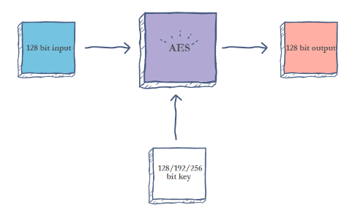

Figure 1. Working of AES.

4.3.1) How does AES work?
The AES algorithm uses a substitution-permutation, or SP network, with multiple rounds to produce ciphertext. The number of rounds depends on the key size being used. A 128-bit key size dictates ten rounds, a 192-bit key size dictates 12 rounds, and a 258-bit key size has 14 rounds. Each of these rounds requires a round key, but since only one key is inputted into the algorithm, this key needs to be expanded to get keys for each round, including round 0.
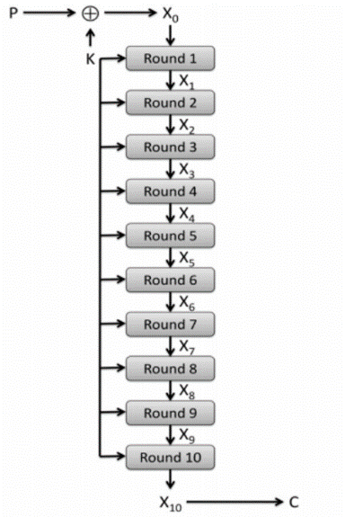
Figure 2. Substitution.

4.3.2) STEPS IN EACH ROUND
There are 4 steps in each round of the algorithm.

1. Substitution of the bytes
In the first step, block text bytes are replaced by predefined S-box rules (shorter by replacement boxes).
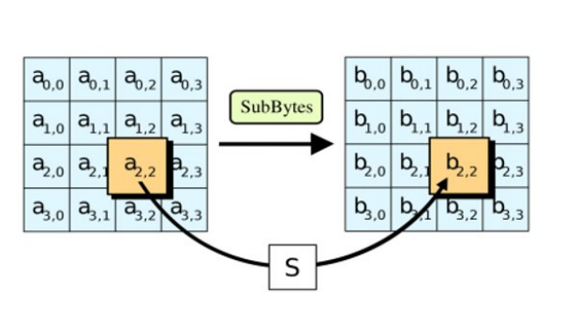
Figure 3. Shifting.
- Shifting the rows
Next comes the approval step. In this step, all the lines except the first one are changed individually, as shown below.
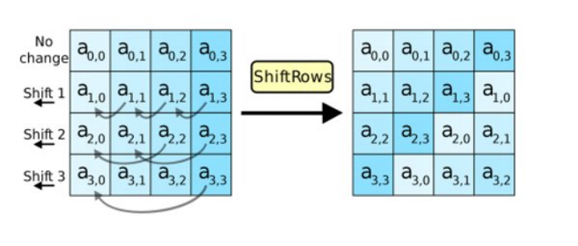
Figure 4. Mixing.
3. Mixing the columns
In the third step, the Hill cipher is used to compose a message by mixing block columns.
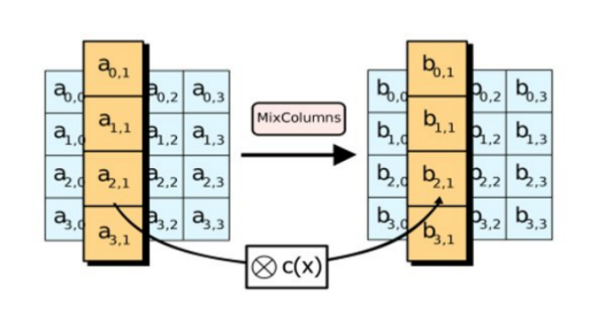
Figure 5. Adding.

- Result and discussion

In this undertaking we need to ensure the record with extraordinary inspiration. In this case, there are two sections there is one client side and the other administrator side. On the client side, just the individuals who will transfer information as a document. After that on the overseer side, there are four administrators accessible. In the event that the main client needs it the document they should be acknowledged by the other three individuals simultaneously as it were the individuals who will utilize the document in any case don't get the record. Principle The thought process is, if the primary client needs a document with three different individuals Admission is vital so just the candidate will utilize the record. It is known that all tolerant information is put away in different configurations in conventional wellbeing conveyance models, suppliers, labs, payers (for example insurance agencies) and medication organizations, and none support of similar guidelines. This prompted information penetrates and the interruption we see today in the trading of wellbeing records.

Dazzle Information sharing foundation likewise upset medication congruity revelation and exploration on general wellbeing. Endeavors to fix this issue it is particularly centered around authorizing another designation rate all through that nature. These endeavors were fruitless on the grounds that the guideline, the enrollment, and patient detachment of the patients expeditiously declined. Because of deficiencies Successful preparing and trade of wellbeing information has forestalled far and wide acknowledgment of the act of changing treatment to him the characteristics, wants and assumptions for the patient. Custom medications – or explanation - has for some time been known as the eventual fate of medical services, and mechanical administrators have given critical assets to advancement for medical services alternatives customized to you, just for the time being framework. Utilizing blockchain innovation, our agreement based medical services The administration plan has shown how the standards of decentralization can be accomplished utilized in the clinical biological system for the administration of enormous information and this improve on complex treatment systems.

We show something new clinical records the executives framework, giving reviewing, joint effort and availability through shrewd arrangements. Intended to record adaptability and granularity, this program empowers sharing of patient information and impetuses to help the clinical examination program. We have proposed likely applications for blockchain innovation in wellbeing data the executives. We utilized an information framework the board and partaking in agreement with clinical necessities vision. Utilizing blockchain innovation, protection, security, accessibility and great control of EHR information access can be guaranteed. The primary reason for utilizing the blockchain in the way portrayed in this paper is to do this improving medical services cycles and hence having patient results. The Blockchain can help from numerous points of view; diminish exchange costs through shrewd agreements which are implanted strategies for the universally useful of improving on measures, decreasing managerial weights and eliminating organizers. Other blockchain endeavors intend to improve the assortment, use and sharing of wellbeing data from patients, agents and processors under the information. Our own the proposed framework utilizes blockchain innovation to make medical services an iterative, adaptable, secure, available and engaged environment. This will permit patients to trade their clinical records all the more openly securely with specialists, emergency clinics, research associations and more members — all while keeping up full power over their security clinical information. This will tackle large numbers of the current medical care frameworks issues, including information extraction, inheritance organization flimsiness, unstructured trouble of information assortment, high regulatory expenses, absence of information security, and solo protection concerns. Contingent upon the current configuration to call the active worker will keep a standard information base.

So as an foundation, authorities first, should pick with clients of brought together subtleties. At the point when you join, for singular clients they will get the CSP key. After that they can sign in with clients abilities, which can trade all data identified with treatment and sickness and how you manage that issue, everything will be traded over the long run after some time, the worker will give security. That will be filed by the utilization of the AES calculation, so now the record is secure in the data set. Presently, a the similar article will see each client if an individual identified with that account worker. So on the off chance that they need a course activity on that illness can select that infection and send posterity Archive solicitation, and afterward identified with the chronicle demand, the solicitation will go to pressure focus. In the event that the recuperation community sees that demand, just that client can get to that record and report the key. In the event that that The office requires a pass way for that record. They'll need to come in the CSP key for the client, will at that point affirm (if conceivable). See will get some information about whether the two keys were right, in which case the client can download report.

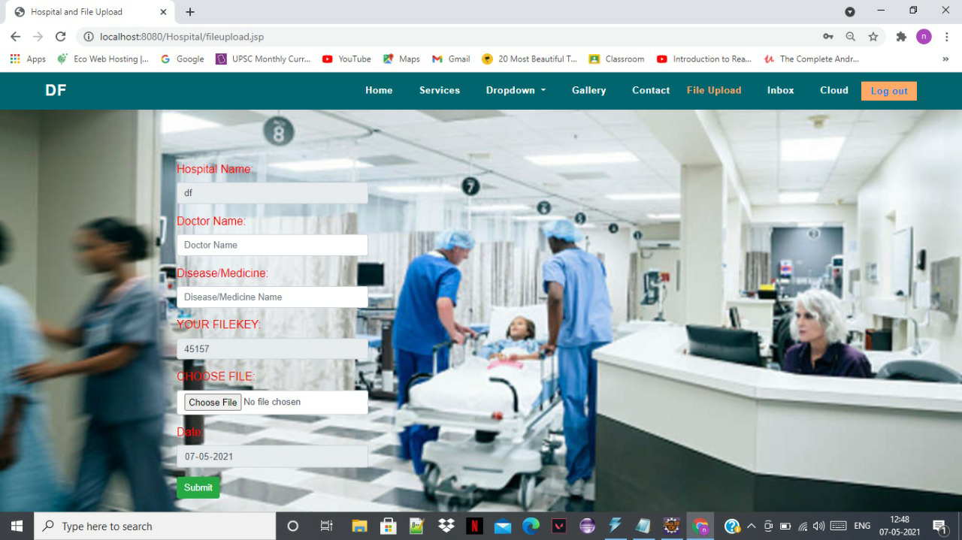

Figure7.The homepage of the server with spaces to fill all the details

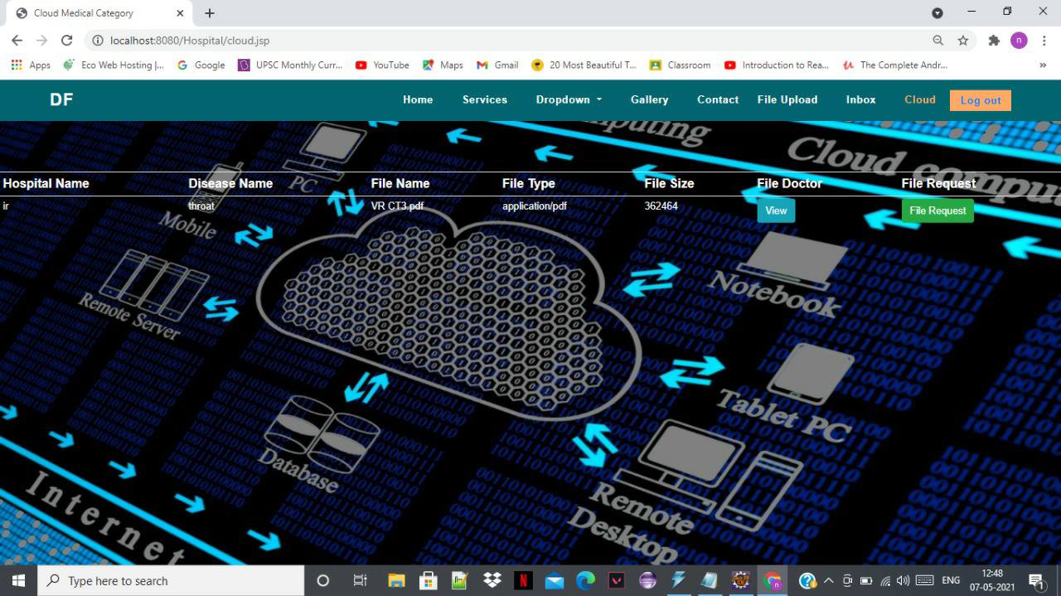
Figure 8. The detail page for result
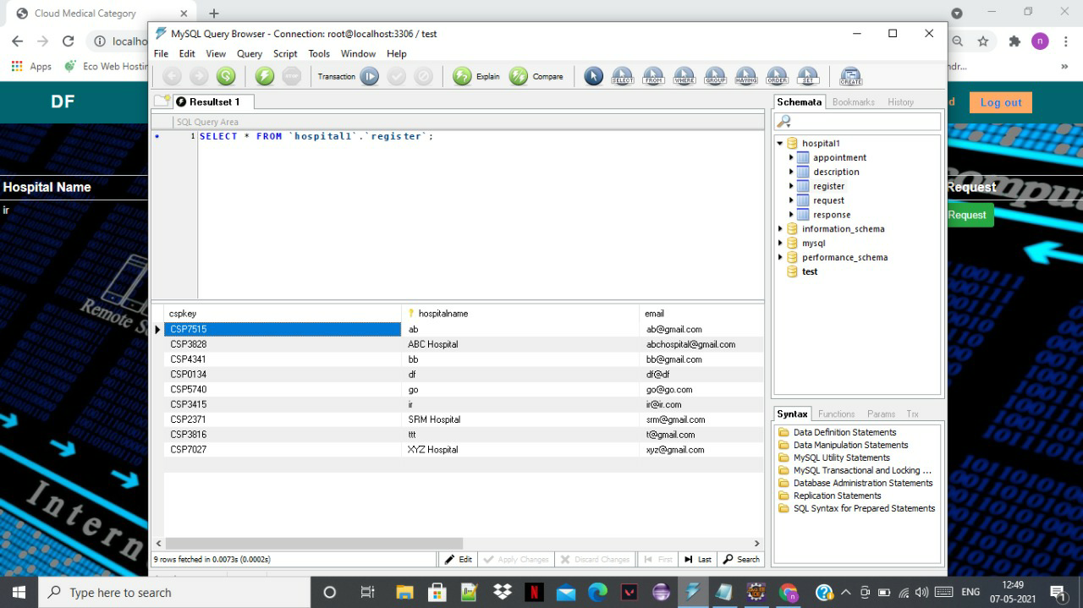
Figure 8. Database

Refrences

  - M. Steward, “Electronic Medical Records,” Journal of Legal Medicine, vol. 26, no. 4, 2005, pp. 491–506.
  - R. Hauxe, “Health Information Systems—Past, Present, Future,” Int'l Journal of Medical Informatics, vol. 75, no. 3–4, 2006, pp. 268–281.
  - K. Häyrinena et al., “Definition, Structure, Content, Use and Impacts of Electronic Health Records: A Review of the Research Literature,” Int'l Journal of Medical Informatics, vol. 77, no. 5, 2008, pp. 291–304.
- M. Ciampi et al., “A Federated Interoperability Architecture for Health Information Systems,” Int’l Journal of Internet Protocol Technology, vol. 7, no. 4, 2013, pp. 189–202.
- M. Moharra et al., “Implementation of a Cross-Border Health Service: Physician and Pharmacists’ Opinions from the epSOS Project,” Family Practice, vol. 32, no. 5, 2015, pp. 564–567.
- S.H. Han et al., “Implementation of Medical Information Exchange System Based on EHR Standard,” Healthcare Informatics Research, vol. 16, no. 4, 2010, pp. 281–289.
- D. He et al., “A Provably-Secure Cross-Domain Handshake Scheme with Symptoms-Matching for Mobile Healthcare Social Network,” IEEE Transactions on Dependable and Secure Computing, vol. PP, no. 99, 2016; doi.org/DOI:10.1109/TDSC.2016.2596286.
- F.Y. Leu et al., “A Smartphone-Based Wearable Sensors for Monitoring Real-Time Physiological Data,” Computers and Electrical Engineering, 2017.
- M. Memon et al., “Ambient Assisted Living Healthcare Frameworks, Platforms, Standards, and Quality Attributes,” Sensors, vol. 14, no. 3, 2014, pp. 4312–4341.
- P.C. Tang et al., “Personal Health Records: Definitions, Benefits, and Strategies for Overcoming Barriers to Adoption,” Journal of the American Medical Informatics Assoc., vol. 13, no. 2, 2006, pp. 121–126.
- S. Marceglia et al., “A Standards-Based Architecture Proposal for Integrating Patient Health Apps to Electronic Health Record Systems,” Applied Clinical Informatics, vol. 6, no. 3, 2015, pp. 488–505.
- Baskar, M., Renuka Devi, R., Ramkumar, J. et al. Region Centric Minutiae Propagation Measure Orient Forgery Detection with Finger Print Analysis in Health Care Systems. Neural Process Lett (2021). Springer, January 2021. https://doi.org/10.1007/s11063-020-10407-4.
- Arulananth, T.S., Balaji, L., Baskar, M. et al. PCA Based Dimensional Data Reduction and Segmentation for DICOM Images. Neural Process Lett (2020). November 2020. https://doi.org/10.1007/s11063-020-10391-9.
- M. Baskar, J. Ramkumar, Ayush Bharadwaj, Yattik Sihag, “Discounts and Profitability Analysis using Data Visualization Techniques”. International Journal of Advanced Science and Technology, Vol. 29, No.06, pp: 2258 – 2270, ISSN: 2005-4238, May 2020.
- M .Baskar, J. Ramkumar, V.Venkateswara Reddy, G.Naveen Reddy, “Cricket Match Outcome Prediction using Machine Learning Techniques”, International Journal of Advanced Science and Technology, Vol. 29, No. 4, pp: 1863-1871, ISSN: 2005-4238, April 2020.
- M .Baskar, J. Ramkumar,Ritik Rathore, Raghav Kabra, “A Deep Learning Based Approach for Automatic Detection of Bike Riders with No Helmet and Number Plate Recognition”, International Journal of Advanced Science and Technology, Vol. 29, No. 4, pp: 1844-1854, ISSN: 2005-4238, April 2020.

